Contents
1 Introduction 3
1.1 Purpose and Scope 4
1.1.1 Introduction To The Original PREQ399 Design Goals 4
1.1.2 Original CommsData Plug-in and Framework Goals 4
1.1.3 Back Port Design Goals 5
2 Design Overview 6
2.1 CommsData client side ESock Framework 6
2.2 CommsData Plug-in 6
2.3 RConnection Extension and Mimicking Behaviour 6
3 Detailed Design 8
3.1 CommsData client side ESock Framework 8
3.1.1 Overview 8
3.1.2 UML Diagram 9
3.1.3 Design Unit Behaviour 10
3.2 CommsData Plug-in 11
3.2.1 Overview 11
3.2.2 UML Diagram 12
3.2.3 Design Unit Behaviour 14
3.3 RConnection Extension and Mimicking Behaviour 15
3.3.1 Overview 15
3.3.2 UML Diagram 16
3.3.3 Design Unit Behaviour 18
4 Scenarios 20
5 Design Considerations 24
5.1 Error Handling and return paths for Error Codes 24
5.2 Targeted Symbian OS Release 24
5.3 Binary Compatibility 25
5.4 Platform Security 25
5.5 Enforced Modularity 25
5.6 Master Code Line (MCL) Impact 25
6 Further Information 26
6.1 References 26
6.2 Open Issues 26
6.3 Glossary 26

Introduction
CR1039 responds to customer needs by providing a back port of a subset of the future functionality from PREQ399 to an earlier release of Symbian OS. The functionality being back ported is the ability to query a connection for information about it’s configuration and current state. The same functionality currently appears as a set of functions on the RConnection class within the ESock component. In the later release of Symbian OS these functions are deprecated and replaced by one function. The interfaces being replaced in the later version are type specific functions GetIntSetting(…), GetBoolSetting(…), GetDesSetting(…) and GetDesLongSetting(…). The function replacing all of these is GetParameters(…). CR1039 proposes back porting enough functionality to replace GetIntSetting(…) and GetBoolSetting(…). This back port should also provide the basis of extending the set or parameters that can be returned.

This document covers the proposed implementation to fulfil the requirements of CR1039.

Purpose and Scope
The GetParameter functionality has been originally developed to be released as part of the PREQ399 project. This project is targeted at a SymbianOS v9.5 delivery. This CR covers the functionality back ported from PREQ399, the elements left for binary compatibility (BC), and source compatibility (SC) with future releases, and the specific implementation produced for the pre PREQ399, SymbianOS v9.4 targeted implementation. This document actually covers an existing proposed implementation. It is intended to allow a formal review of the proposed implementation and to ensure that the new code being added to the MCL will match up with the new features and requirements of the future release.
It would be beneficial if the reviewer has knowledge of ESock, and the NetMeta subsystem.
Before examining the design presented within this document it is important to consider the original future design goals the concerning bit of functionality had been intended to address. The original design forms part of the PREQ399 project. This is a large project covering numerous areas of the networking subsystem. CR1039 brings forward a small sub set of functionality originally intended for deployment in PREQ399. The resulting design deployed in CR1039 will not contain all the elements provided in PREQ399, however this early deployment has to be forward binary compatible with the eventual solution. This implies that the eventual design CR1039 releases to MCL will contain unused extensions and segments of code that are only present to support the final solution. As such it is advantageous to study some of the original design goals set out by this segment of the PREQ399 project.

Introduction To The Original PREQ399 Design Goals
It is intended that licensees should not need to modify esock, PREQ399 enforces this. One of PREQ399’s design goals is to eventually produce a solid flexible ESock component that will not need to be modified by licensees to support their requirements. Instead licensees will supply new plug-ins or modified configuration files to tailor the behaviour of the ESock component to their specific needs. The specific functionality required by GetParameters(…) concerns the ability of an application developer to query a provider for information about an on going connection, or a configured connection. Typically this information is supplied by a particular provider. The provider will itself form part of a plug-in. Therefore when a new provider is added by a licensee the licensee would supply the provider plug-in and a plug-in which allows an application developer to query the provider for information. In addition a system supplied plug-in provides information on a base set of information provided by the ESock component it’s self. The PREQ399 Design depicts not only a query ‘get’ method but also a ‘set’ method to modify connection settings. The subset of PREQ399 that CR1039 concerns is just the plug-in used by application developers and the plug-in’s associated framework. These elements are referred to throughout this document as the CommsDataObjects plug-in and frame work.

Original CommsDataObjects Plug-in and Framework Goals
The original plug-in goals are tightly tied to the underlying structure being developed by the PREQ399 project. The original intention is that the plug-in used to compose a query for getting information from the system will also provide the method of answering the query. The query ECOM plug-in breaks down into two sections, the data holder containing the information about the requested data along with the result, and a second segment which represents the request as message within the mesh machine. The PREQ399 project ensures that server side within the ESock component that a mesh machines exists which handles requests from user side APIs. Messages are passed between nodes through the mesh machine in a structured manor until one node can answer the request. Using this method the plug-in created by the licensee and used by the developer to construct a query can navigate itself through the mesh machine until it discovers a node that implements an interface that the query can use to obtain the information requested by the application developer constructed query. This set of goals encompasses client and server side ESock solution.

Similar functionality already exists providing the same information as suggested above. The existing functions providing this are the RConnection::GetXSetting(...) functions, where X is Bool, Int, Des and LongDes. These functions return one specified piece of information at a time, for instance if an application developer required the ID of the IAP currently in use and the Network ID for that IAP they would invoke this function twice once for each piece of information. This can be inefficient as in order to service a function call a context switch is invoked as the ESock server is called to answer each request. Therefore another major goal is to provide more than one piece of information for every context switch. An application programmer constructed query could request information about both the number of bytes sent, and the number received and have both requests answered in the one function call requiring only one context switch. The CommsDataObjects plug-in and frame work are intended to form part of the ESock API. The specific functionality to process a query object is exposed from the existing RConnection class, and the original GetXSetting(...) functions will be deprecated in a future OS release.

Back Port Design Goals
The aim of this back port is to provide application developers with the same interface PREQ399 will present to query the RConnection for information. The PREQ399 design uses a mesh machine to allow for new and existing providers to answer any queries generated by an Application Developer. However as previously mentioned the mesh machine and provider backend plug-in frame work is not covered by the unit of work being back ported. This unit of work only covers the plug-in visible to an application developer and its supporting ESock supplied frame work. This back port does not need to provide extended support for the query to navigate between nodes, as without a complete PREQ399 implementation the required mesh machine does not exist. There is no additional support to allow provider supplied plug-ins. The system supplied query plug-in will not be complemented with a sibling. However it is necessary to ensure that forward compatibility exists. This will enable applications written to use the back ported API to run unmodified with the new API when it is delivered. The back port should replicate the user perceived behaviour exhibited by the full PREQ399 implementation. The back ports own implementation can differ considerably as long as it maintains this same set of perceived behaviour and forward compatibility.

Design Overview
The intention of this design is that by using the original GetXSetting functions which already exist within the RConneciton class the back port will be able to perform in an identical manor, replicating the perceived functionality provided in PREQ399. To do this it is necessary to map a request issued as a CommsDataObject query to a call to one of these existing GetXSetting functions. The back port only brings forward the specific areas of ESock which provide the CommsDat plug-in and Frame work. It does not bring forward any additional components or enhanced components used by the PREQ399 implementation. As a result the back port can not bring forward the functionality to request settings held as descriptors. This design only provides the functionality to request integer or Boolean settings and will only support the get functionality.

These design goals help break down the design into three areas, the first area is within ESock and supports ECOM plug-ins. The second area is the CommsDataObjects plug-in it’s self which represents a query. The third area is the RConnection interface change to support the new functionality.

The CommsDataObjects plug-in can be broken down further to produce data section holding the query / response, and a message like API designed for the mesh machine. It is possible to provide stubbed out functions to fulfil the forward compatibility requirements imposed by PREQ399 and the mesh machine related functionality but will exclude any actual functionality from the message passing / mesh machine dependent areas. It is only necessary to provide the functionality required by the application developer, this is the ability to create a query, submit it to RConnection and to have the query completed. To supply this functionality CR1039 needs to provide the following:
- CommsDataObjects client side ESock Framework
- CommsDataObjects plug-in
- RConnection Extension

CommsDataObjects client side ESock Framework
In order to add support for a new pluggable framework the ESock unit is extended with the addition of three new base classes.

CommsDataObjects Plug-in
The plug-in consists of a suite of query objects representing the differing data types it’s possible to generate queries for. This consists of integer, unsigned integer, and Boolean data types. It also supplies the classes required to create a collection of these queries and to associate them together in order to submit multiple queries at the same time. In addition to aid application developers the plug-in also provides a utility class which provides a quick way to process returned query responses.

RConnection Extension and Mimicking Behaviour
The ESock client side extensions also contains the additional function added to the RConnection class and the supporting utility functions and data structures to support mimicking the original functionality.
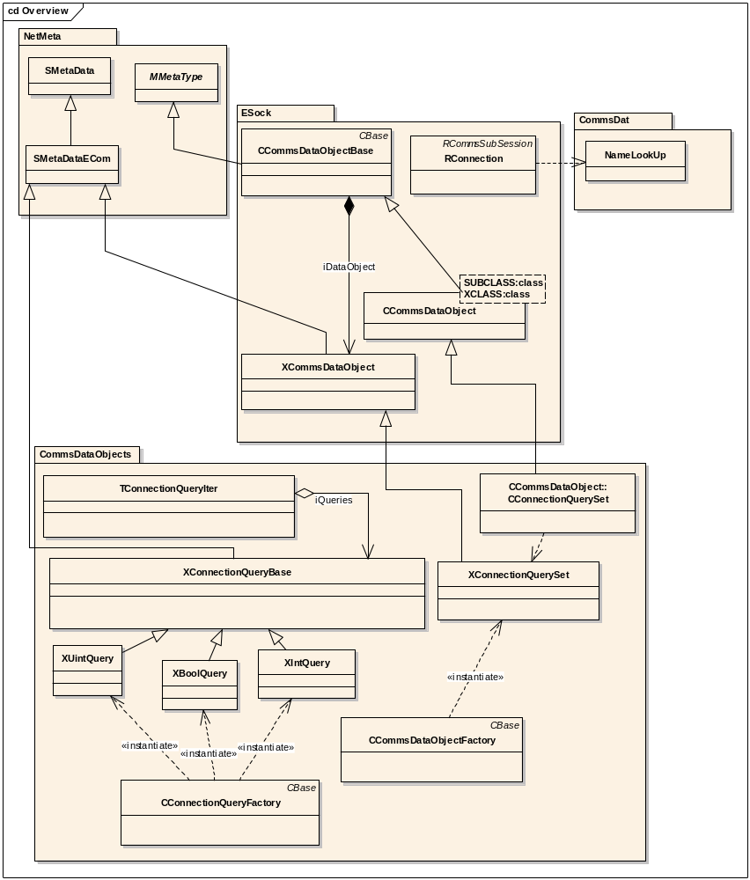
Figure 1 Overview of all classes involved in design

The UML Diagram shown above covers all the classes covered in this back port. This diagram will be elaborated on and covered in more detail in the following detailed design section. This document will break down the design into three major areas; CommsData client side ESock Framework, CommsDataObjects plug-in, RConnection extension and mimicking the original functionality. Each section it be covered in more detail.

Detailed Design
This section elaborates on the 3 design unit blocks identified in the previous segment, with the use of UML diagrams and descriptions it aims to highlight the major structures which are intended to be submitted to the MCL.

CommsDataObjects client side ESock Framework
This design unit covers the extensions proposed to the ESock client side unit to provide support for the new framework.

Overview
The framework makes use of the NetMeta package to provide classes which can be serialised. This allows for easy transfer of objects across an IPC boundary. These break down into a data payload ‘X’ object and a ‘C’ based access controller / creator object which provides managed access to and the overall serialisation functionality for the data. The framework provides the necessary base classes for all CommsDataObject plug-in objects. The CCommsDataObjectBase class provides the base class for all query data objects. The XCommsDataObject provides the base class for all of the data objects. Both of these base classes provide basic functionality and data common to all plug-ins. In addition a templated class CCommsDataObject provides type safe factory functions for creating instances of the intended plug-in supplied derived class, and a type safe access to the XCommsDataObject derived data class. These three main classes are added to support CommsDataObjects plug-in and are covered in more detail in the following section.

UML Diagram
The following diagram covers the additional support classes added to the ESock component to support the CommsDataObjects plug-in.

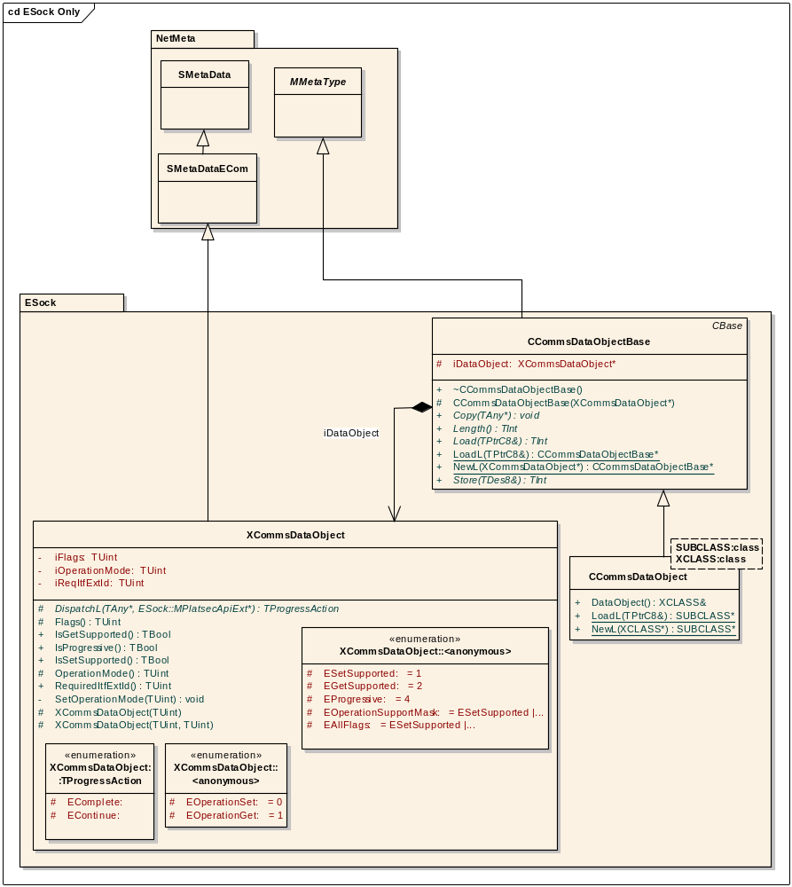
Figure 2 UML Diagram showing ESock extensions to support the CommsDataObjects Plug-in

CCommsDataObjectBase.
This class provides basic serialisation functionality, implementing the NetMeta functions Copy, Length, Load and Store.

XCommsDataObject.
Probably the most interesting class covered in this design section, this class provides support for the common settings associated with the CommsDataObjects plug-in. In the future some plug-ins may only support the setting of values, while others may only support the getting of values. The base class presented here provides support for the storing and retrieval of values. It is intended that the actual data value should be stored and manipulated by derived classes provided by the plug-in. XCommsDataObject provides a generic way for the frame work to query the capabilities of the plug-in.

Design Unit Behaviour
NetMeta derived classes are usually simple data structures with little additional functionality and the main classes covered in this section follow this pattern.

CommsDataObjects Plug-in
This unit covers the Plug-in which is supported by the classes introduced in the previous section. This design unit provides basic access to system wide connection properties.

Overview
The CommsDataObjects plug-in supplies the set of queries which can be issued. The frame work derived class XConnectionQuerySet provides a collection of queries which can be issued in one go to the RConnection class. Each of the individual queries is derived from the NetMeta class XConnecitonQueryBase. These classes and some helper utility classes are discussed in more detail below.

UML Diagram
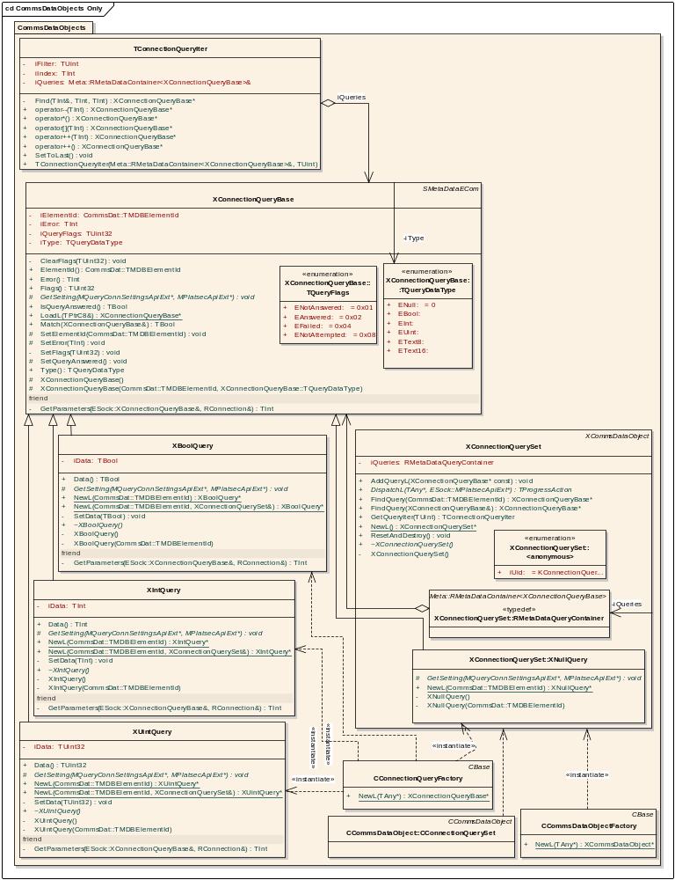
Figure 3 UML Diagram Showing Plugin implementation

XConnectionQuerySet.
This class provides a collection of query objects. It directly fulfils the requirements of the base class XCommsDataObject. It supplies an array like interface to allow new queries to be added. These queries must exist within the plug-in and be supplied by derived classes from the XConnectionQueryBase.

XConnectionQueryBase.
This class provides generic access to common properties shared across all individual queries. This includes the state of the query (has it been answered yet or not) and any possible error code. The actual query is expressed by a CommsDat data type TMDBElementId. This is a 32 bit, bit field which expresses properties about the data item being requested, this is explained in more detail in the “RConnection Extension and Mimicking Behaviour” section below. The iQuery flags is an other bit field set with values from the TQueryFlags enum. This allows expressive statements on the state of a query. These expressive statements can then be used when examining returned queries. The TConnectionQueryIter is a utility class designed to make use of these expressive statements. The XConnectionQueryBase class provides a pure virtual function all children must implement, this function GetSetting(...) is designed to be used by the PREQ399 implementation of DispatchL. It is not utilised in CR1039’s implementation but is kept for future compatibility since as a pure virtual function affects the size of the class’s vtable.

TConnectionQueryIter.
This class provides a convenient way of iterating through a collection of returned queries. In order to create a TConnectionQueryIter object it is necessary to specifying the set of entries you which to iterate through, and also specify a specific filter to be applied to this set. The TConnectionQueryIter class will limit the entries it provides to ones which match you chosen criteria. iFilter stores the query flags to match on the queries iQueryFlags field, and iIndex is the current position within the collection. The XConnectionQueryBase class described above contains a utility function which provides an easy way to construct a TConnectionQueryIter.

XBoolQuery, XUintQuery, XIntQuery and XConnectionQuerySet::XNullQuery.
The child classes of XConnectionQueryBase all provide type safe implementations complete with iData field for storing the returned value, during construction they provide the correct data type information to the base class. This allows the framework to get a specific query to obtain the data type it expects to receive. As visible on the diagram the XConnectionQueryBase::TQueryDataType enumeration contains entries for 8 bit and 16 bit text based data types. As stated in the Design Overview these data types are supported in a future release but are not provided within CR1039. XNullQuery provides a concrete implementation of XConnectionQueryBase but does not specify any returned data type. This allows a “NULL” instance of a query to be used internally.

The NewL Symbian constructors provided within these classes has an overloaded version which accepts both the requested ID value and a reference to a XConnectionQuerySet, this modified function automatically adds the query to the set.

CConnectionQueryFactory
The CConnectionQueryFactory class provides a factory function to return an instance of a query object. The TAny* parameter passed in to the NewL function is actually expected to be a enumerated value from the XConnectionQueryBase::TQueryDataType enum. Attempts to generate instances of unsupported data types result in the function leaving with the error KErrNotSupported.

CCommsDataObjectFactory
This class provides a factory constructor, NewL to create instances of XConnectionQueryState. The input to the NewL function is expected to be the ID of the XConnectionQuerySet class.

Design Unit Behaviour
The majority of the plug-in supplied classes are ‘X’ type classes which are simple data structures, and have little further functionality.

The future PREQ399 release will build on these classes and provide extra functionality allowing a plug-in to provide programmatic support for obtaining the information requested using the mesh machine principles and the XCommsDataObject::DispatchL(…) function, however this is beyond the scope of CR1039.

RConnection Extension and Mimicking Behaviour
The RConnection extension further extends the ESock component to provide the RConnection::GetParameters(…) function. To do this the design unit needs to convert the TMDBElementId used by the plug-in into a string name which can be issued to one of two other RConnection’s functions, GetBoolSetting, and GetIntSetting. The following covers how this is done, and how the back port mimics the behaviour of the future code base to be supplied in PREQ399.

Overview
This section covers in detail the algorithm used to convert the TMDBElementId bit field into a string suitable for submission to the existing GetBoolSetting / GetIntSetting functions. The back ported interface RConnection::GetParameters(...) makes use of a support function within a new namespace ConnectionExtension. This function traverses a set of read only data structures to determine the correct string. This is covered in more detail in this section

UML Diagram
The UML Diagram highlights the major components used in the algorithm and the additional new function added to RConnection, and the new class and function added to CommsDat.

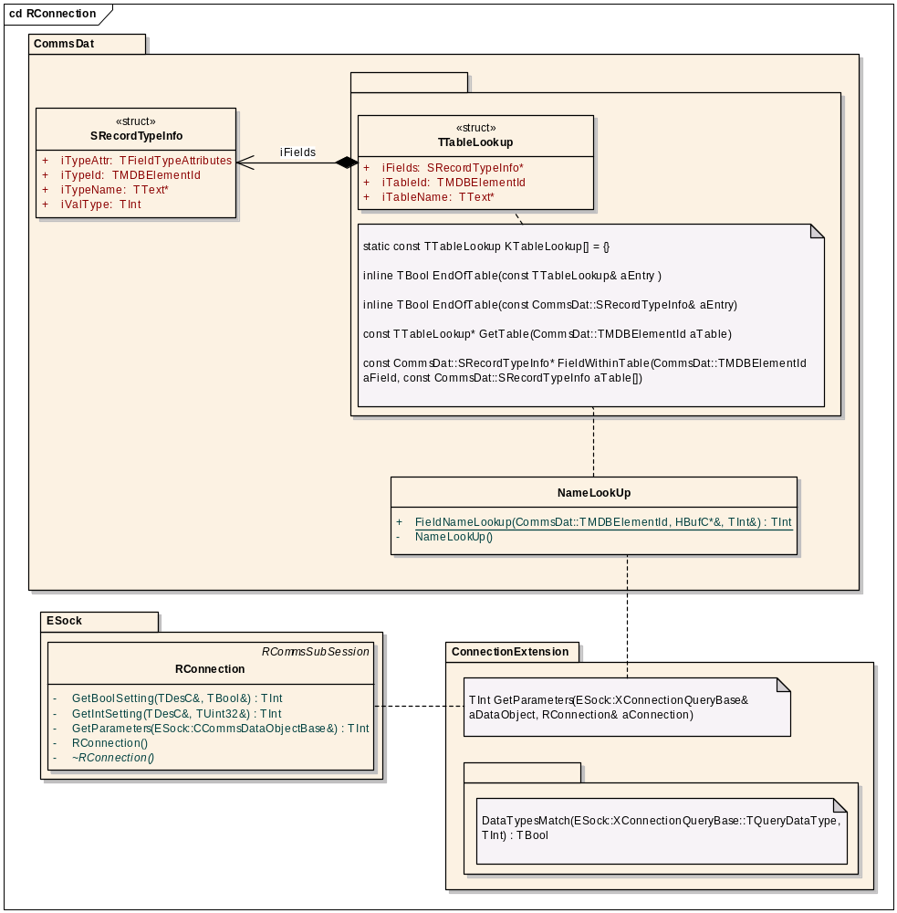
Figure 4 UML Diagram covering RConnection modifications

RConnection::GetParameters.
Once composed queries are submitted to the RConnection interface via the GetParameters(...) function. This function makes use of the ConnectionExtension::GetParameters function. This function in turn makes use of the data structures and functions stored within the nameless namespace.

Connection Extension Nameless Namespace
The following functions and data structures are all defined within the nameless name space. This namespace means that all functions and data types are only available within the .cpp file in which they are defined. The ConnectionExtension name space and the GetParameters function are defined within the same .cpp as the nameless namespace, and therefore are able to utilise definitions created within the nameless namespace.

DataTypesMatch(...).
This function returns a Boolean indicating if the ESock::XConnectionQueryBase supplied data type matches the data type stored in the CommsDat data type format TCDFieldValueTypes.

CommsDat Changes
The CommsDat component contains an existing collection of tables each depicting the field structure represented by each known table within the commdb. In order to convert a TMDBElement into a string based descriptor it is necessary to access these fields. These tables are static arrays of SRecordTypeInfo data structures. Although these tables provide information on the contents of a table, they do not provide information on the table it’s self. Information such as the table name is not supplied. To be able to convert from the numeric representation to a string based representation it is necessary to associate a table ID number with a table name and the correct SRecordTypeInfo table. The TTableLookup structure meets this requirement.

SRecordTypeInfo.
The CommsDat component supplies an already existing data type, SRecordTypeInfo, which contains information on a record ID’s mapping to a field entry. It stores the field name it maps to, and the data type associated with it. Arrays of this type of data structure are referenced by entries in a list of the tables. The global list of tables is based on the TTableLookup data type.

CommsDat Nameless Namespace
The following functions and data types are used within a nameless namespace encapsulated within the CommsDat component.

TTableLookup.
This structure stores the name of table, an ID representing the table, and a pointer to an array of SRecordTypeInfo describing the list of fields stored within the table.

EndOfTable(...).
The end of each table is marked by an empty entry. This is detected by the overloaded function EndOfTable(...). When given an entry from either of the TTableLookup or SRecordTypeInfo tables both implementations of this function return a Boolean value indicating the end of the table has been reached.

GetTable(...).
Given a table ID this function will select the correct matching entry from the KTableLookup table. If it is impossible to find a matching entry a NULL pointer is returned.

FieldWithinTable(...).
Supplying a list of fields selected from the found table entry this function searches for an entry which matches the supplied ID value. If a matching entry can not be found a NULL pointer is returned.

NameLookUp class
This class provides the CommsDat Symbian internal API allowing esock component to request the conversion of a TMDBElementId into a descriptor based string. The following function is a member of this class.

NameLookUp::FieldNameLookup(...).
This function takes an field ID bit field and returns a newly constructed descriptor with the required string needed for use with the RConnection::GetXSetting functions. It returns an error if this is not possible otherwise the supplied HBufC pointer will contain the valid address of a newly constructed HBufC descriptor.

Design Unit Behaviour
This section describes the how these functions and data structures interact to provide the string to submit to the GetXSetting functions. It also shows how these functions mimic the behaviour of the PREQ399 original implementation.

RConnection::GetParameters(…) Behaviour
The following section looks in the depth at the implementation of the function:

TInt RConnection::GetParameters(ESock::CCommsDataObjectBase& aDataObject)

Unusual PREQ399 behaviour
On closer examination the RConnection::GetParameters(...) function has two return paths for errors. The first is the integer return code. If an error occurs and none of the queries held within the container can be processed the integer value will contain an error code. The second is the iError field within the XConnectionQueryBase, if an individual query can not be processed, or fails, it’s error is recorded here. In this situation the RConnection::GetParameters(...) function will return KErrNone even though an error has occurred.

Mimicking PREQ399 behaviour
To mimic the PREQ399 behaviour it is necessary to perform some basic checks prior to invoking any of the subsequent functions. These checks are identical to the original implementation. The first check ensures that the get operation is supported by the CommsDataObject, the second ensures that the right type of CommsDataObject has been supplied by verifying the ID of the object. Then processing of the individual queries can begin. This is where the CR1039 implementation starts to differ significantly from the PREQ399 implementation. The CR1039 implementation is written in the client-side code of ESock. The implementation breaks up the collection of queries and deals with each individual query one at time. For each individual query an IPC will occur. Although this negates some of the performance benefits of PREQ399 to allows the API to be delivered significantly ahead of the PREQ399 schedule. Using this approach means that no check can be made that the connection is started, this is the final reason why none of the items could be processed. In the PREQ399 implementation KErrNotReady is returned if the connection is not started, and the state of the query object submitted to the function is not changed. If this error is returned by one of the GetXSetting() methods then every item within the query should have their iError value set to KErrNone, their iQueryFlags field set to ENotAttempted. This ensures that each item has returned to it’s original state. Further processing is abandoned and the function should return the error code. This then mimics the behaviour of PREQ399.

Assuming that the server is started each query item is selected from the collection and submitted to the ConnectionExtension::GetParameters(...) function. If this function returns any other error code apart from KErrNotRead then the error code is copied to the query’s iError field. The iQueryFlag field is set to indicate that the query has not been answered and it failed. If no error occurs then this field is set to indicate a successful completion. In both conditions processing continues onto the next query and no error code is returned from the function.

The RConnection::GetParameters(...) passes each individual query through to the ConnectionExtension function.

ConnectionExtension::GetParameters(…) Behaviour
The next section focuses on the implementation of the following function:
namespace ConnectionExtension
{
TInt GetParameters(ESock::XConnectionQueryBase& aDataObject, RConnection& aConnection)
};
Accepting an individual query object this function performs some preliminary checks on the data type, before attempting to obtain a field name, and data type from a helper function FieldNameLookup(....). Once successfully completed the FieldNameLookup function returns the data type stored in the table, and the completed field name. The GetParameters(...) function verifies that the expected data type from the table and the data type requested by the caller match before issuing the correct version of GetXSetting. The queries data structure is then corrected populated with the error code and returned data from the GetXSetting call.

FieldNameLookup(…) Behaviour
The following function is covered in more detail below:

TInt NameLookup::FieldNameLookup(CommsDat::TMDBElementId aElementId, HBufC*& aFieldName, TInt& aDataType)
This function performs the task of converting an element ID into a string formatted as follows:
“table-name/field-name”

To do this the function processes the TMDBElementId bit field, the following diagram describes the bit field layout. The CommsDat unit provides a set of constant masks to allow developers to manipulate the bit field. These are identified in the diagram below.

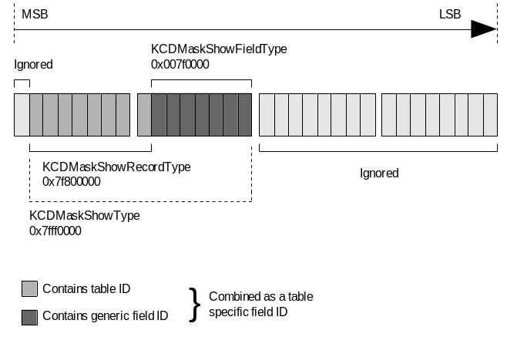
Figure 5 CommsDat::TMDBElementIDBitStructure

Fields are broken into two types, table specific fields and generic fields. Generic fields are stored within a table with a TMDBElementId consisting only the last 7 bits of the second byte in the 32 bit word, these are fields which are common to more than one table. Unique or table specific fields which apply only to a specific table are stored within the table as a TMDBElementId consisting of the bottom 7 bits of the first byte and all 8 bits of the second byte. There is no way to know when the field being requested is generic or not.

The FieldNameLookup(...) function works by first stripping out the unneeded bits, isolating the bits identifying the table ID using the KCDMaskShowRecordType mask. It then attempts to locate the table using this ID. If this is successful it searches the list of fields associated with that table using the original cleaned up ID received by the function, this is the table specific ID. If it finds no records matching this ID it strips everything bar the generic field ID bits using the KCDMaskShowFieldType mask and searches the list of fields again.

Once this function has both a pointer to the correct table entry, and a pointer to the correct field entry it allocates the memory for a heap based descriptor and creates the required string. It then returns both the newly created string and the type information from the field entry selected.

If this function fails at any of these checks it returns an error code, otherwise on successful completion it will return KErrNone.

Scenarios
The following annotated code shows scenarios where the design units co-operate to produce both an error and the required data set. This code segment assumes the use of a set of macros for displaying information to the user, FPRINTx(…) macros, where x is the number of arguments. This code segment is expecting to be executed as part of a Symbian console application.
void ExampleCodeL()
{

The first section of this function connects to the socket server and the RConnection, sub session.
TInt error;
RSocketServ socketServer;
User::LeaveIfError( socketServer.Connect() );
CleanupClosePushL( socketServer );

RConnection connection;
User::LeaveIfError( connection.Open(socketServer) );
CleanupClosePushL( connection );
This next section of code creates a new query set. Using the connection query child classes it populates the query set with a list of queries. The last query deliberately uses an incorrect data type. This will be used later on to show the error handling mechanisms that are in place. Unfortunately the ‘X’ type classes are not derived from CBase and yet they are placed on the heap. This breaks expected Symbian coding standards. When an ‘X’ object is placed on the clean up stack and destroyed using CleanupStack::PopAndDestroy(). It’s destructor is not invoked. To over come this issue it is necessary to place ‘X’ type objects on the cleanup stack using the CleanupDeletePushL() function.
XConnectionQuerySet* querySet = XConnectionQuerySet::NewL();
CleanupDeletePushL(querySet);

XConnectionQueryBase* query;
query = XBoolQuery::NewL(CommsDat::KCDTIdIpAddrFromServer, *querySet);
query = XUintQuery::NewL(CommsDat::KCDTIdLastSessionClosedTimeout, *querySet);
// KCDTIdIfPromptForAuth is a Boolean value, this should be a boolean request, not an integer
query = XUintQuery::NewL(CommsDat::KCDTIdIfPromptForAuth, *querySet);
The CConnectionQuerySet container object is then created and populated with the ‘X’ type data holder class. In fact it takes ownership of the ‘X’ object, so the cleanup stack is reordered at this point to reflect this.
CConnectionQuerySet* connectionQuerySet = CConnectionQuerySet::NewL(querySet);
CleanupStack::Pop(querySet);
CleanupStack::PushL(connectionQuerySet);

// ---------------------------------------------------------------------
// RConnection API additional method test
// ---------------------------------------------------------------------

This first test attempts to invoke the GetParameters(…) function without starting the connection. The result should be an error code returned by the application.

// This should fail with KErrNotReady since the connection hasn't been started
error = connection.GetParameters(*connectionQuerySet);
FPRINT2("first call to GetParameters, is %d", error);
ASSERT(error == KErrNotReady);

The second test attempts the same call, but this time after starting the connection.
// This should succeed, but the last query should fail because of the bad data type.
User::LeaveIfError( connection.Start() );
error = connection.GetParameters(*connectionQuerySet);
ASSERT(error == KErrNone );
FPRINT2("second call to GetParameters, is %d", error);
The out above outputs the following information to the console:
Figure 6 GetParameters error information
The next section of example code iterates through the collection of queries displaying the results to the user. There are three methods of accessing the results, either directly via index, directly by searching for an ID, or using the TConnectionQueryIter data type to iterate through a set of results.
TBool booleanValue = EFalse;
TInt signedIntergerValue = 0x0F0F0F0F;
TUint32 unsignedIntegerVaue = 0xF0F0F0F0;
TInt count = 0;
Note: boiler plate code to ensure that the function has in fact completed without any IPC related errors.
if (error == KErrNone)
{
XConnectionQuerySet& outputQuerySet = connectionQuerySet->DataObject();
Create the TConnectionQueryIter object using the utility function GetQueryIter from the XConnectionQuerySet class.
TConnectionQueryIter iter (outputQuerySet.GetQueryIter(XConnectionQueryBase::EAnswered));
Starting with the first found result and while there are results to process, obtain the returned value and display it to the user.
const XConnectionQueryBase* qBase = iter++;
while (qBase)
{
TUint32 untypedData = 0;

count++;
// Get data and display it on the screen.
switch (qBase->Type())
{
case XConnectionQueryBase::EInt:
{
const XIntQuery* qInt = static_cast<const XIntQuery*>(qBase);
signedIntergerValue = qInt->Data();
untypedData = static_cast<TUint32>(signedIntergerValue);
}
break;

case XConnectionQueryBase::EUint:
{
const XUintQuery* qUInt = static_cast<const XUintQuery*>(qBase);
unsignedIntegerVaue = qUInt->Data();
untypedData = static_cast<TUint32>(unsignedIntegerVaue);
}
break;

case XConnectionQueryBase::EBool:
{
const XBoolQuery* qBool = static_cast<const XBoolQuery*>(qBase);
booleanValue = qBool->Data();
untypedData = static_cast<TUint32>(booleanValue);
}
break;
default:
break;
}

FPRINT4("Index[%02d], Id[0x%08X], Error[0x%08X], Value[0x%08X]",
count, qBase->ElementId(), qBase->Error(), untypedData);
qBase = iter++;
}
The code shown above outputs the following on a Symbian console:
Figure 7 Illustration of successfully returned data from a query
The following code searches for a query within the set based on a given ID. It attempts two searches the first will definitely fail.
// Option 2 - Get a query response directly
const XConnectionQueryBase* directQuery = NULL;
directQuery = outputQuerySet.FindQuery(CommsDat::KCDTIdIfNetworks); // wont be found
FPRINT2("FindQuery() can\'t find KCDTIdIfNetworks and returns[0x%08X]", directQuery);
ASSERT( directQuery == NULL );

directQuery = outputQuerySet.FindQuery(CommsDat::KCDTIdIfPromptForAuth);
FPRINT2("FindQuery() CAN find KCDTIdIfPromptForAuth and returns[0x%08X]", directQuery);
PAUSE;
ASSERT( directQuery != NULL );
FPRINT2("KCDTIdIfPromptForAuth query errored, it\'s iError is [%d]", directQuery->Error());
ASSERT( directQuery->Error() == KErrArgument);

FPRINT3("Bad Request, Id [0x%08X], Error[0x%08X]", directQuery->ElementId(), directQuery->Error()); }
The code shown above produces the following output on a Symbian console:
Figure 8 Illustration of the contents of a failed query
Finally before finishing this function cleans up the resources we have consumed. The connectionQuerySet owns all the objects used in the construction of the original query and in the parsing of the results. It actually owns the querySet pointer, so it is not necessary to delete this pointer. However to avoid confusion it’s shown being set to NULL here.
CleanupStack::PopAndDestroy(connectionQuerySet);
querySet = NULL;
connection.Stop();
CleanupStack::PopAndDestroy(); // connection.Close();
CleanupStack::PopAndDestroy(); // socketServer.Close();
}

Design Considerations
This section provides a recap on some of the design goals or other considerations which influenced the final design.

Error Handling and return paths for Error Codes
The new functionality provided by PREQ399 provides two methods of providing an error response. The PREQ399 RConnection::GetParameters(…) returns an error code if communication with the server fails, or if the query object is not supported. The XConnectionQueryBase::iError contains the error code associated with an individual request. This behaviour is mimicked in the back port design. The diagram below visualises the two returns codes present in the proposed design.

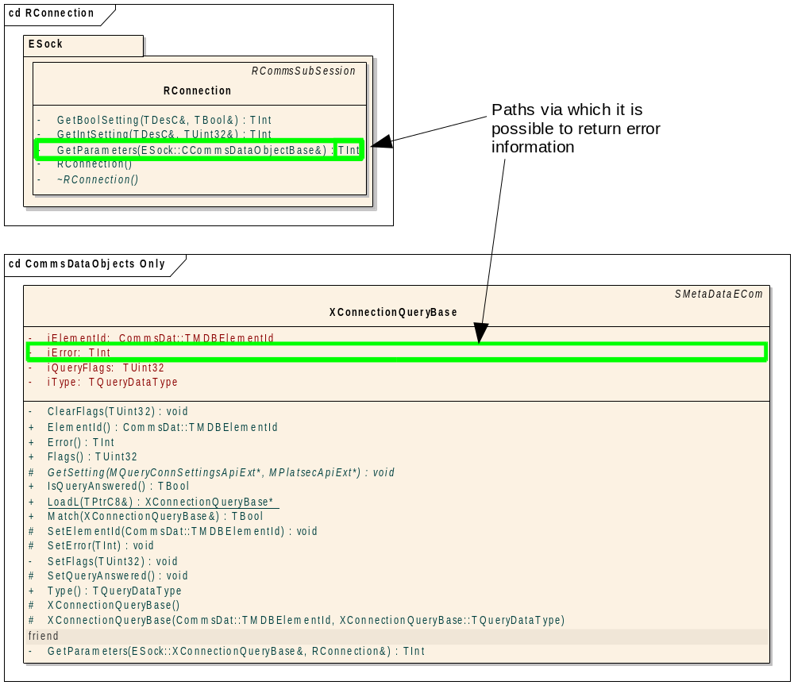
Figure 9 UML excerpt showing error code return paths

Targeted Symbian OS Release
It is assumed that this design will bring forward PREQ399 functionality to Symbian OS release 9.4.

Compatibility
As stated earlier in the design document it’s necessary for the back port to be 100% forward compatible with the forth coming PREQ399 release.

Platform Security
Platform security considerations are removed from this proposed implementation. The capabilities are not explicitly handled by the design, instead the RConnection::GetXSetting(…) functions have already implemented the security check. This design relies on these functions ensuring that the calling process has the correct capabilities. The future PREQ399 implementation will conform to the same set of capabilities.

Enforced Modularity
PREQ399 envisages new types CommsDataObject plug-ins being developed by licensees at a future date. At the moment this not an immediate requirement, however the scope of the design must provide for this functionality to maintain compatibility.

Master Code Line (MCL) Impact
This code will be delivered to the MCL prior to PREQ399 being delivered. The intention is that when PREQ399 delivers to the MCL it will replace the functionality implemented based on this design with a fully compatible equivalent solution making full use of the PREQ399 features and functionality.

Further Information

References
No. | Document Reference | Version | Description
[R1] | NetMeta_Design_Document.doc | 1.2 | Design document for NetMeta
[R2] | ESock_Design.doc | 2.0 | Design document describing ESock
[R3]

Open Issues

Glossary
Term | Definition
BC | Binary Compatibility
SC | Source Compatibility
MCL | Master Code Line
IAP | Internet Access Point

